The Five Themes

of

World Studies

CULTURE
Culture-the way of life of a group of people.
*Material Culture
*Non-Material Culture

GOVERNMENT
Government-the ruling authority for a nation, state, or community.
*The U.S. is a republic.

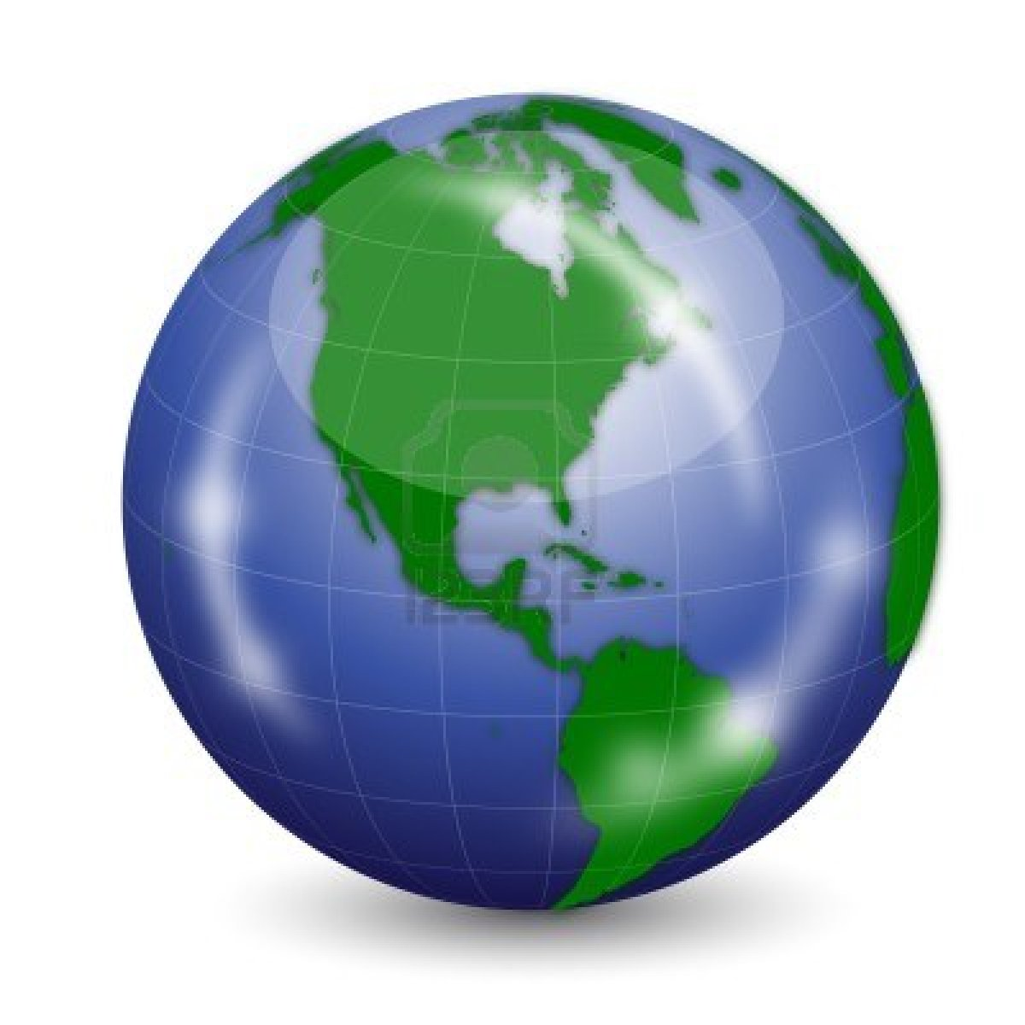

HISTORY
History-the written record of human events.
*Begins in about 5000 B.C. in Mesopotamia.

GEOGRAPHY
Geography-the study of the Earth’s surface and the processes that shape it.
*Physical Geography
*Cultural Geography

ECONOMICS
Economics-system of producing, distributing, and managing goods and services within a society.
*Ex: Free-Market, Command, Mixed

